Alan S. S. Daou

Dr. James Brenner

Molecular Dynamics Simulation

May 3, 2018

# Introduction

While movement of nanoparticles (NPs) in a suspension may appear random, their motion and aggregation are a combination of both diffusion and electrokinetic mobility, and both are affected by a multitude of parameters such as surfactant charges, NP size, the concentration of other species (particularly ions) in solution and temperature. Control over the distribution of particle sizes is central to the nanotechnology industry, particularly with regard to color, electrical properties, catalytic behavior, sensing by electronic noses and tongues, and all other surface properties. To make this possible, nanoparticles (NPs) are typically surrounded by either cationic or anionic surfactants to put a surface charge on the NP’s, thereby ensuring repulsion with similarly charged NP’s. Sometimes NP’s are surrounded by nonionic capping agents that rely solely on the steric bulk of the capping agent to provide a barrier to NP aggregation. Often, capping agents are chosen to provide both an electrostatic and a steric barrier to aggregation.

This project was the molecular dynamics (MD) portion of what will ultimately be a hybrid Monte Carlo (MC) and MD simulation of nanoparticles in an appropriate suspension fluid (as opposed to a solvent) such that the capped NP’s will have a finite chance of interacting with each other and/or with desorbed capping agent ligands. The MD portion of the simulation will approximate the electrokinetic (diffusion plus an electrically-driven convective flow), ultrasonic, and gravitational flows present in NP suspensions. The Monte Carlo portion of the model will simulate the probability for desorption or adsorption of a capping agent ligand with a NP, as well as the reaction of two NP’s with each other to form a single larger nanoparticle.

# Motivation

Nanoparticles exhibit numerous material properties that are different than their bulk counterparts, including higher band gap energy, size-dependent tunable color, enhanced strength, etc. However, as nanoparticles' surface charge dissipates, the NP's aggregate into larger structures. This research will consist of a stochastic (Monte Carlo) simulation of a set of elementary reaction steps into more condensed structures, with the hope of gaining a better understanding of how to prevent such aggregation in the future. Examples of experimental work studying such aggregation include a) the formation of porous synthetic zeolites that are the workhorse of the catalyst industry, b) the nucleation and growth of ammonium dihydrogen phosphate (ADP) common to children's science fair kits, c) Au and Ag nanoparticles; and d) several protein misfolding disorders such as Alzheimer's disease, Parkinson's disease, sickle cell anemia, and others.

An attempt to minimize the Gibbs free energy (G0) of the entire system will force particles to aggregate. The Gibbs free energy can be broken down into a bulk term and a surface term. When the repulsive energy associated with the charges located on the perimeter of each NP is overcome by the attractive energy of two entities becoming one entity, then aggregation occurs. In between, while the NP’s are surrounded by their counterions in suspension, there is a finite probability that ions with the same in charge as the NP’s will attack the hydration layer surrounding the NP’s. Gradually, the surface charge on the NP’s, as typically quantified by the zeta potential, degrades at a rate that is proportional to the total ion concentration in the suspension.

# Literature Review

The base molecular dynamics code has been modified from “The Working Person’s Guide to Molecular Dynamics Simulation” by David Keffer from the Department of Chemical Engineering at the University of Tennessee in Knoxville. This document was provided by Dr. James Brenner and was chosen as the reference to start this project due to its straightforward way of obtaining a molecular dynamics simulation. Keffer's code incorporates the Lennard-Jones potential and Newton equation's of motion, and integrates its ordinary differential equations using Gear's method for . A molecular dynamics document provided by Ron Dror from Stanford provided more insight on the action of surfactants, as well as the Verlet equations of motion.

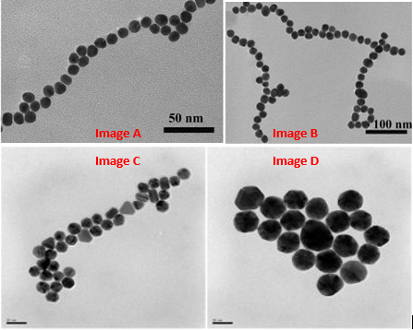

Figure 1 - Nanoparticle aggregation of **?**

Nanoparticles are often approximated as colloidal spheres with a dipole (or as magnetic spheres). If the zeta potential on each NP is high enough, they can form long chains (as seen in Figure 1A). Branching can occur off of such chains or when the chains intersect (Figure 1B). Sintering, defined as aggregation of nanostructures into larger, more condensed structures can result from two parallel chains side by side forming one thicker chain (Figure 1C), and complete condensation into one large entity (Figure 1D). Notice, particularly in Figure 1D, that as the crystal diameters become larger for metallic NP’s, the crystals become much more faceted because certain planes of atoms prefer to be at the surface in order to minimize the Gibbs free energy in the system.

# Code

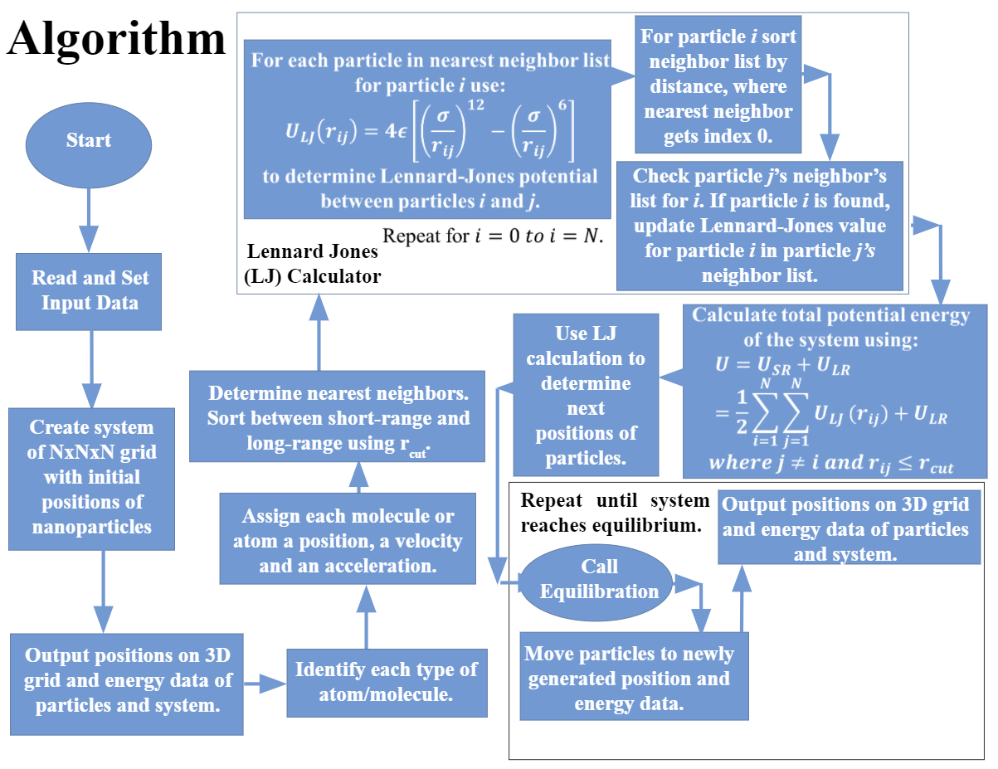

Figure 2: Algorithm

To start the code (Figure 2), the properties of an atom are entered in the system. This ideally will be adapted by subsequent students to accommodate a set of multiple atoms of multiple types. The code then creates a cubic grid of size N (number of atoms) and displays it on screen as seen in Figure 3. Each of the dots represent an atom’s position. Each of the atoms in the grid is then assigned a random velocity and an acceleration of zero. The next step is a nearest neighbour subroutine as well as the Lennard Jones potential energy calculation (top of Figure 2). From the energy calculated, the force is calculated, which combined with the mass is used to calculate the acceleration. From the acceleration, a new value of velocity and position is calculated and the new position is plotted.

In each time step, we must account for:

A) Any metal ions or atoms diffusing

B) Any metal ions or atoms convectively moving due to ion currents

C) Any nanoparticle (NP) diffusion

D) Any NP convective motion

E) Possible reaction between all combos of

1) Two isolated metal atoms/ions

2) One metal atoms/ions + one NP

3) Two NP's

F) Surface diffusion of metal within a NP to minimize NP energy

G) Include formation of grain boundaries

H) Include coalescence of two adjacent grains into one larger grain

# Results and Discussion

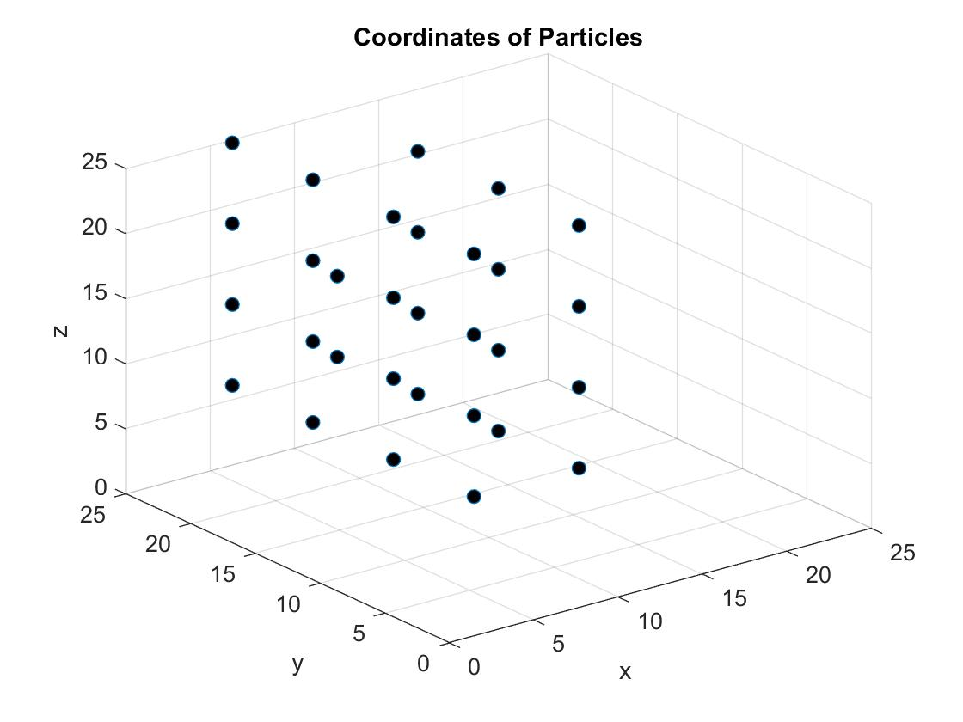

Figure 3: Initial particle positions

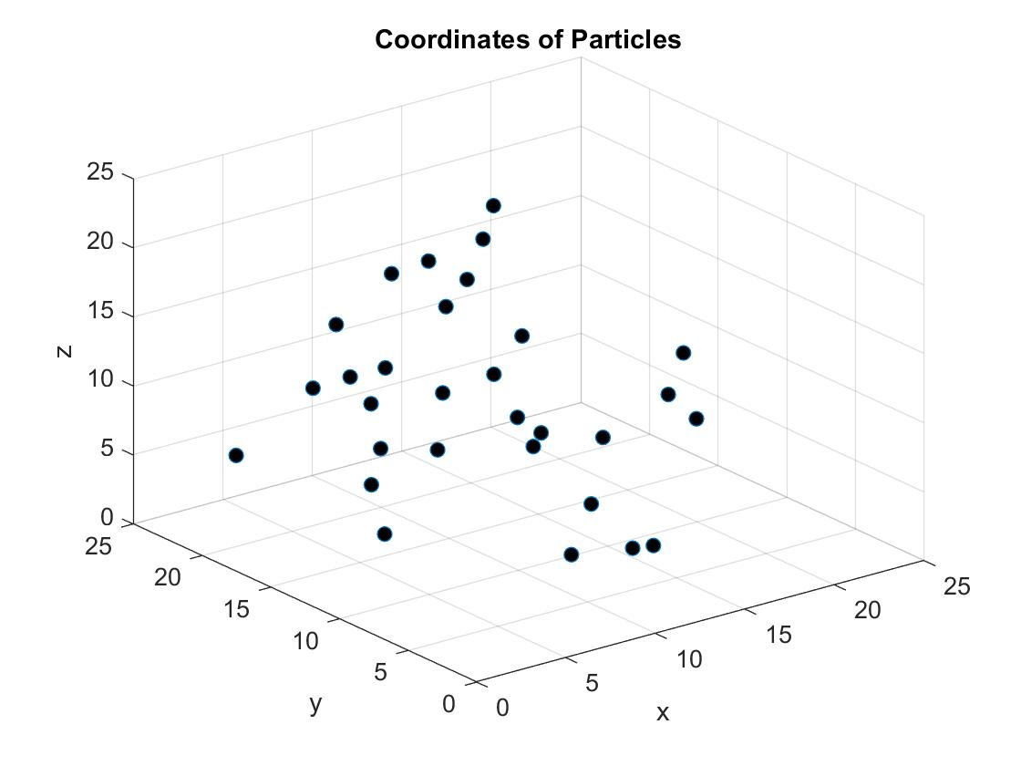

Figure 4: Particle position at random time

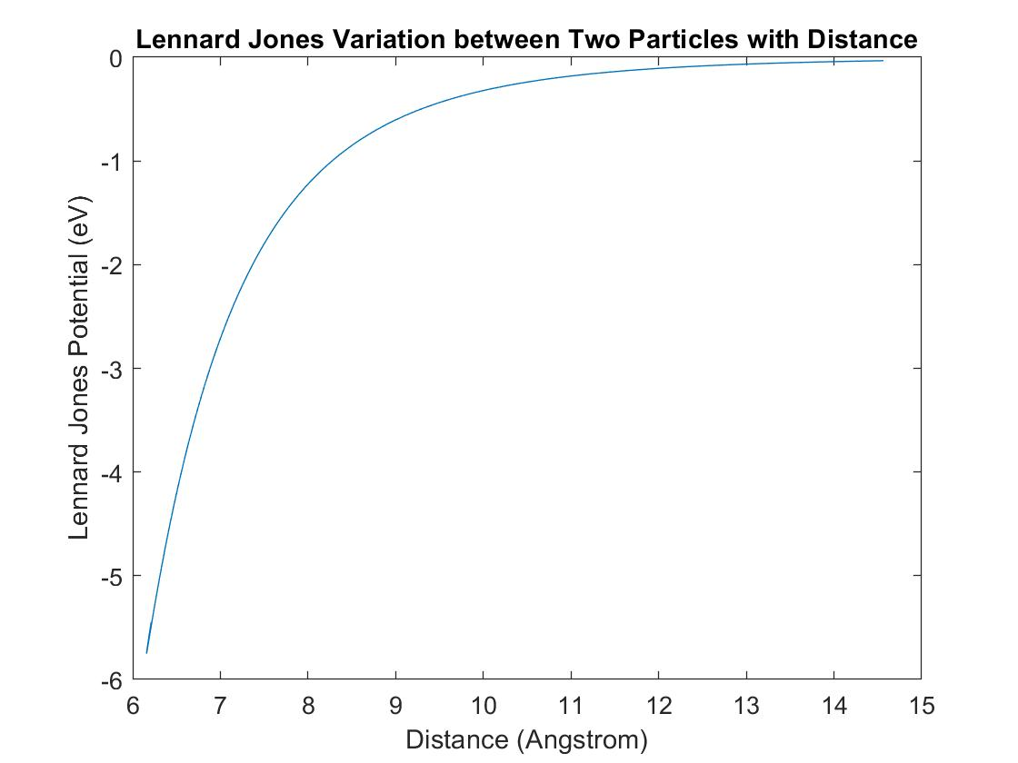

Figure 5: Lennard-Jones potential vs. distance

Although it may not appear like it (Figure 2) because of the difficulties in visualizing 3D spatial positions in 2D, each atom is located equidistant from all its nearest neighbours. Figure 3 shows the positions of atoms at a later time. When two atoms get very close to each other, the Lennard-Jones potential increases dramatically. This resulted in consistent crashes in the code for weeks until a correction implemented:

When the distance between two atoms became sufficiently short, the time step Δt had to be shortened so that the simulation would not crash when the bodies got extremely close. A series of ‘if’ statements was added to handle the situation whenever a body was within 2 or 3 times the possible bond distance.

The code is still missing many components such as way to compute reactions as well as particle aggregation. Adding the effect of surfactants as well as non-homogeneous systems is the next step towards the completion of this project.

Dissemination:

As a first step toward this final report, this simulation was presented at the Northrop Grumman Engineering & Science Senior Design Showcase on 4/6/2018.

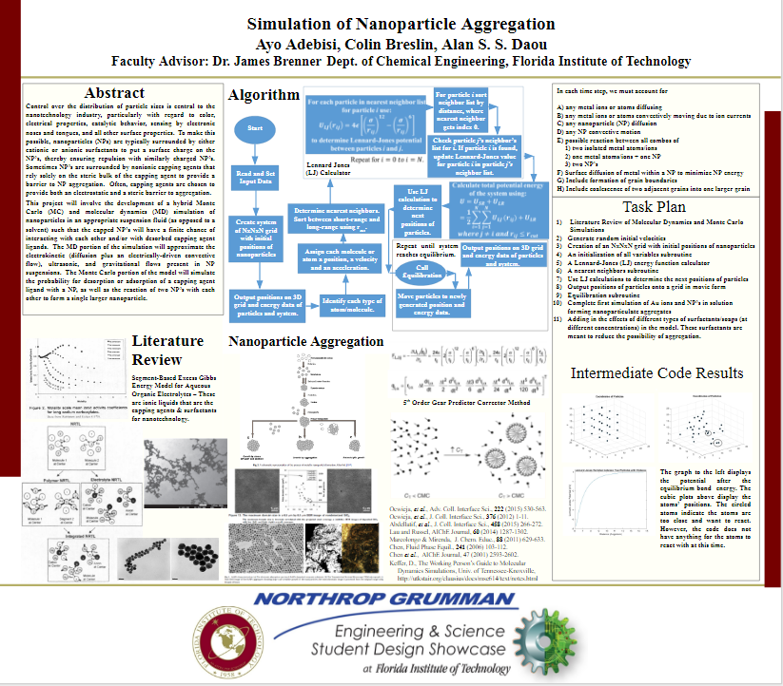

Figure 6: Senior Showcase Poster

# Task Plan

1. Literature review
2. Reading and setting of input data
3. Creation of an NxNxN grid with initial positions of nanoparticles
4. An initialization of all variables subroutine
5. A Lennard-Jones (LJ) energy function calculator
6. A nearest neighbors subroutine
7. Use LJ calculations to determine the next positions of particles
8. Output positions of particles onto a grid in movie form
9. Equilibration subroutine
10. Poster presentation
11. Completed first simulation of Au ions and NP’s in solution forming nanoparticle aggregates
12. Final report
13. Adding in the effects of different types of surfactants/soaps (at different concentrations) in the model. These surfactants are meant to reduce the possibility of aggregation
14. Allowing any metal ions or atoms to convectively moving due to ion currents
15. Possible reaction between all combos of

1) Two isolated metal atoms/ions

2) One metal atoms/ions + one NP

3) Two NP's

1. Surface diffusion of metal within a NP to minimize NP energy
2. Inclusion of formation of grain boundaries
3. Inclusion of coalescence of two adjacent grains into one larger grain

Steps 2 through 12 are completed.

# References

1. Ocwieja, *et al*., Adv. Coll. Interface Sci., **222** (2015) 530-563.
2. Ocwieja, *et al*., J. Coll. Interface Sci., **376** (2012) 1-11.
3. Abdellatif, *et al*., J. Coll. Interface Sci., **458** (2015) 266-272.
4. Lau and Russel, AIChE Journal, **60** (2014) 1287-1302.
5. Marcolongo & Mirenda,  J. Chem. Educ., **88** (2011) 629-633.
6. Chen, Fluid Phase Equil., **241** (2006) 103-112.
7. Chen *et al*.,  AIChE Journal, 47 (2001) 2593-2602.
8. Keffer, D., The Working Person’s Guide to Molecular Dynamics Simulations, Univ. of Tennessee-Knoxville
9. http://utkstair.org/clausius/docs/mse614/text/notes.html